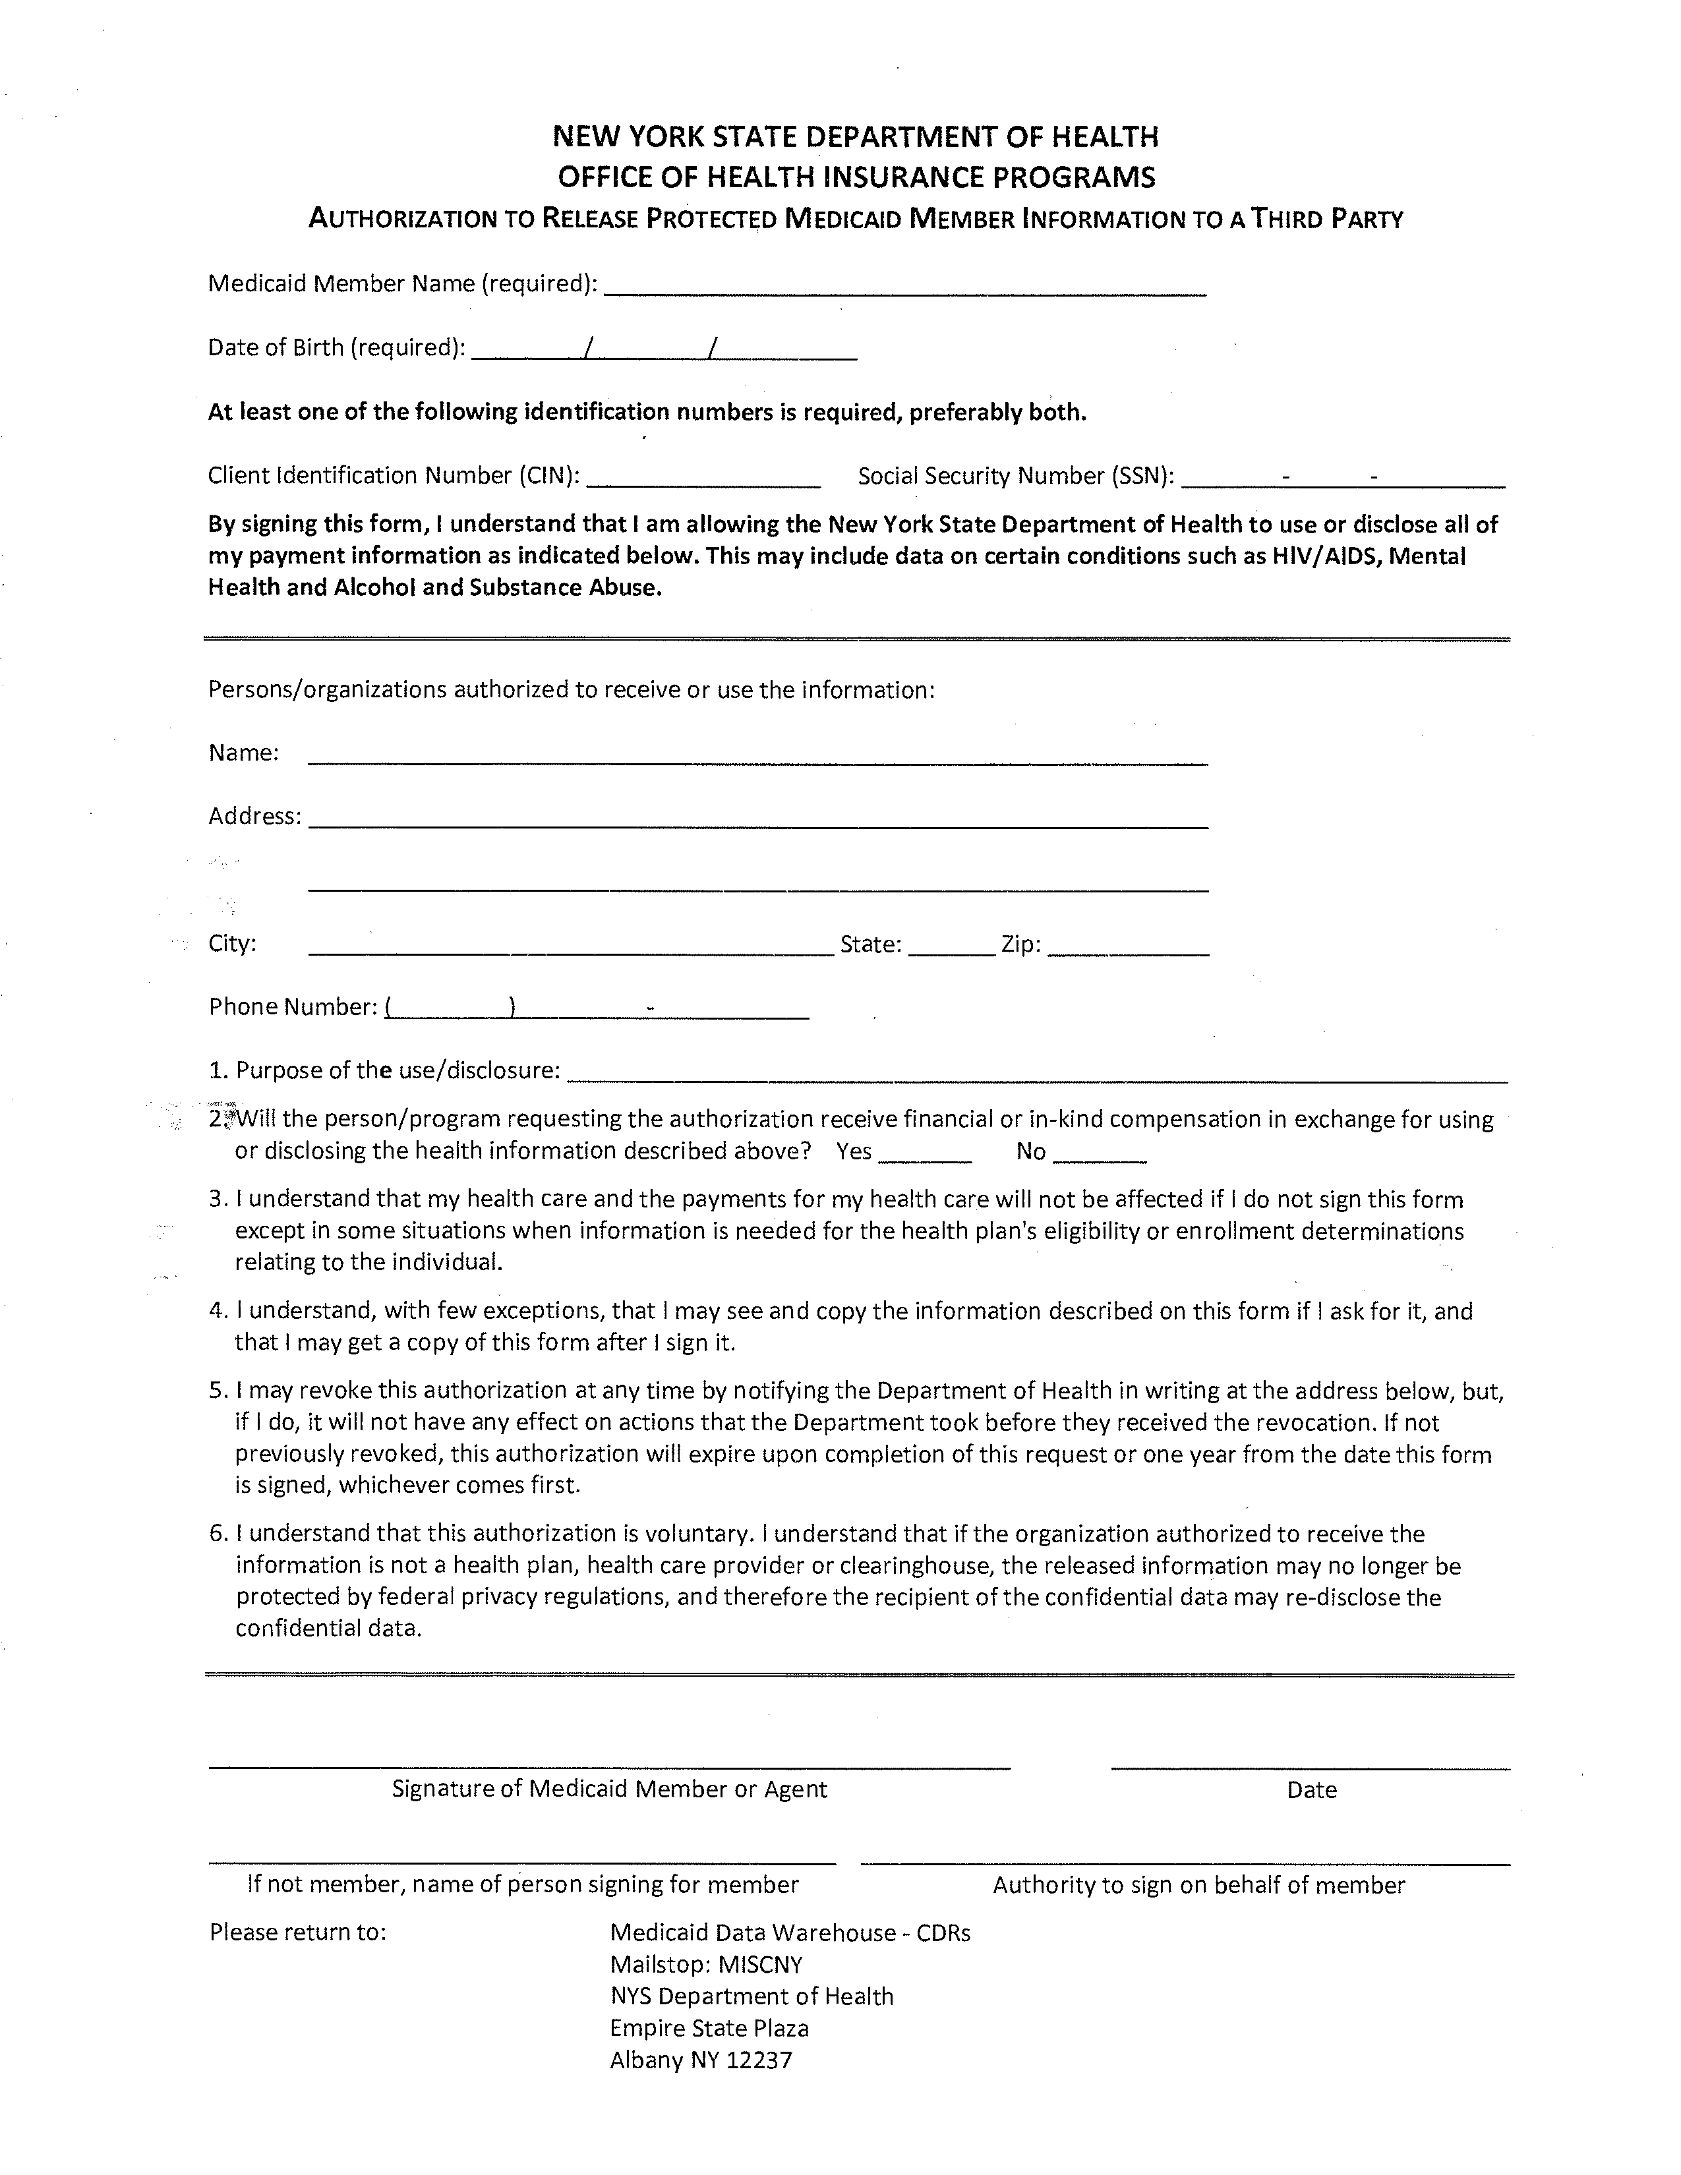
Jocelyn Brooks
03/08/1968
Axiom Requisition Copy Service as agent of Crisci, Weiser & McCarthy
2869 Jolly Road
Okemos
MI
48864
(877) 886-5090
Litigation
X
Order No. 01-28888-002

